### **Project 01**

### **Deploying a Node.js App Using Minikube Kubernetes**

#### **Overview**

This project guides you through deploying a Node.js application using Minikube Kubernetes. You'll use Git for version control, explore branching and fast-forward merges, and set up Kubernetes services and deployment pods, including ClusterIP and NodePort service types.

#### **Prerequisites**

* Minikube installed
* kubectl installed
* Git installed
* Node.js installed ([https://nodejs.org/en/download/package-manager/all#debian-and-ubuntu-based-linux-distributions](https://nodejs.org/en/download/package-manager/all" \l "debian-and-ubuntu-based-linux-distributions))

#### **Project Steps**

### **1. Set Up Git Version Control**

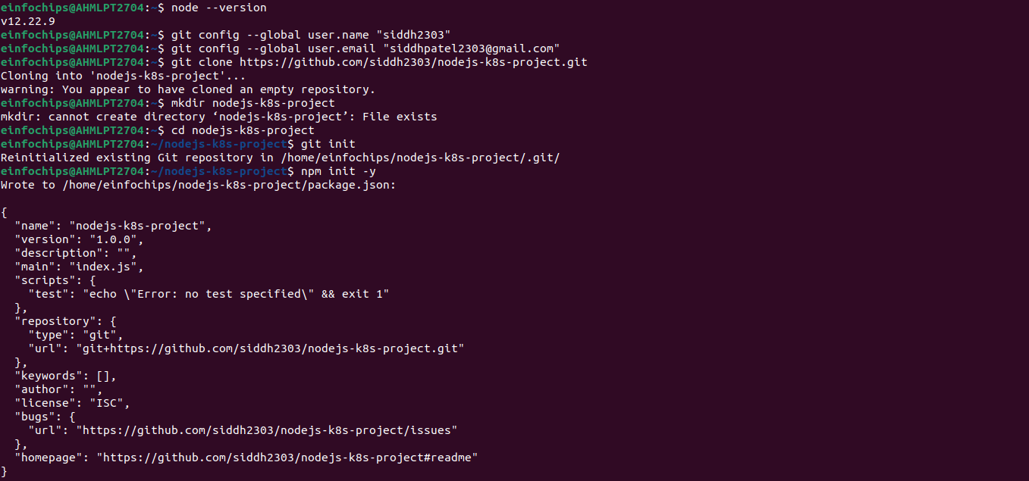

### 

### **2. Branching and Fast-Forward Merge**

**2.1. Create a New Branch**

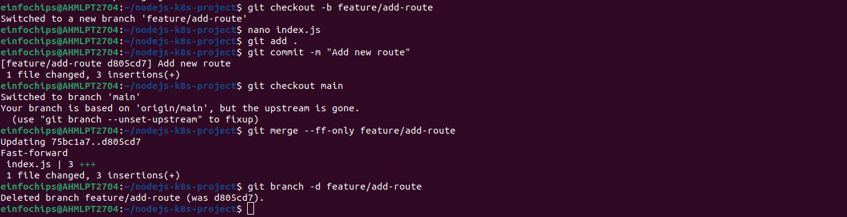

### **3. Containerize the Node.js Application**

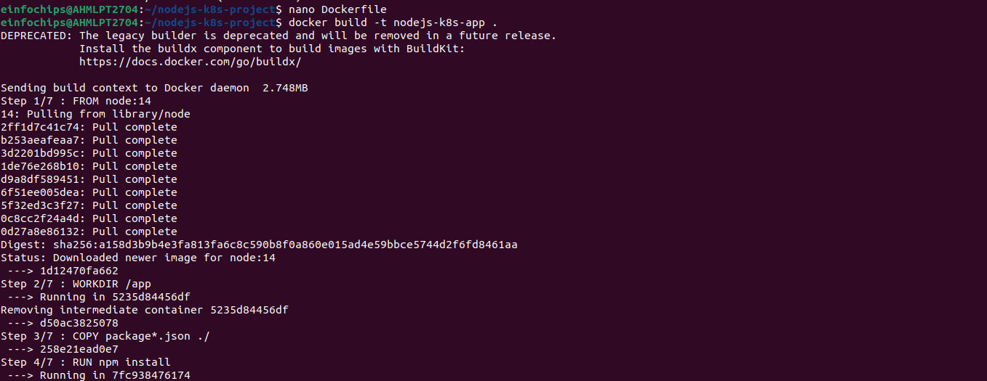

### 

### **4. Deploying to Minikube Kubernetes**





### **Making Changes to the App and Redeploying Using Kubernetes**

### **6. Making Changes to the Node.js Application**

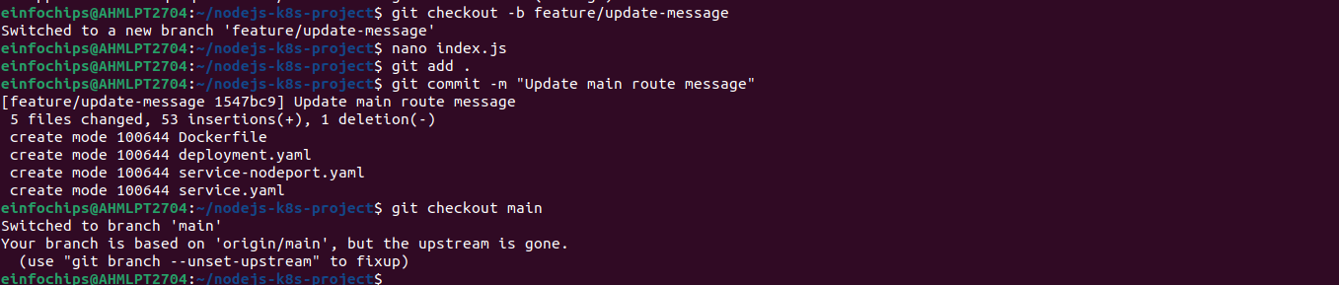

### **7. Merge the Changes and Rebuild the Docker Image**

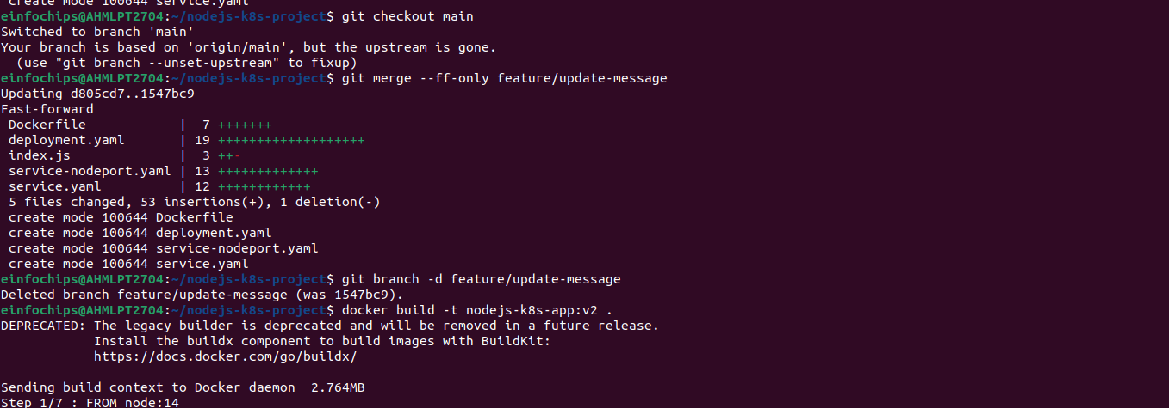

**Project 02**

### **Deploying a Python Flask App Using Minikube Kubernetes**

#### **Overview**

This project guides you through deploying a Python Flask application using Minikube Kubernetes. You'll use Git for version control, explore branching and fast-forward merges, and set up Kubernetes services and deployment pods, including ClusterIP and NodePort service types.

#### **Prerequisites**

* Minikube installed
* kubectl installed
* Git installed
* Python installed

#### **Project Steps**

### **1. Set Up Git Version Control**

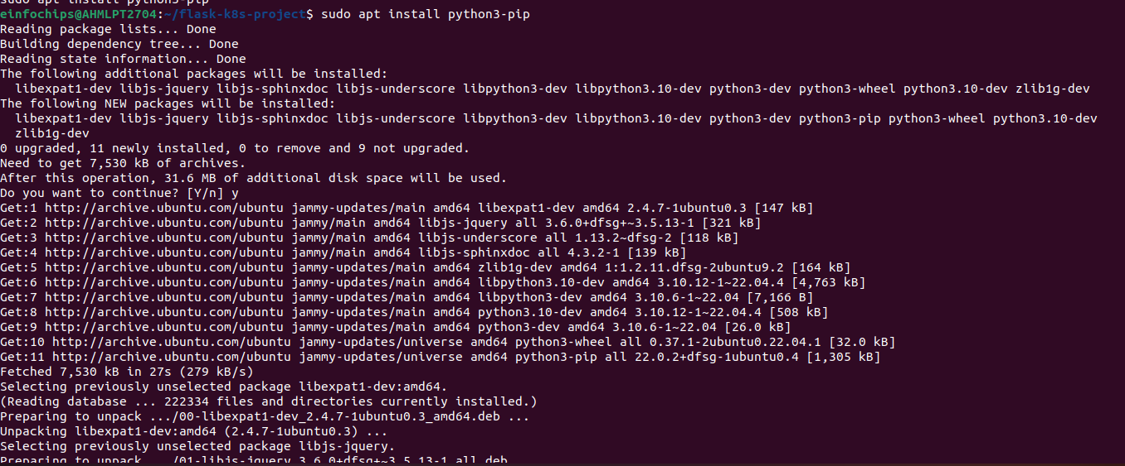

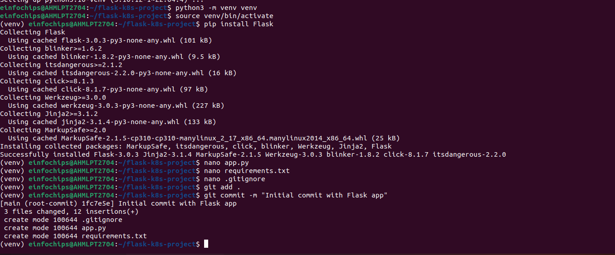

### **2. Branching and Fast-Forward Merge**

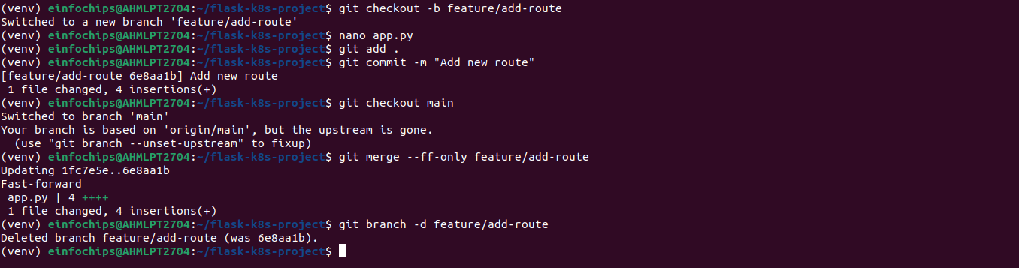

### **3. Containerize the Flask Application**

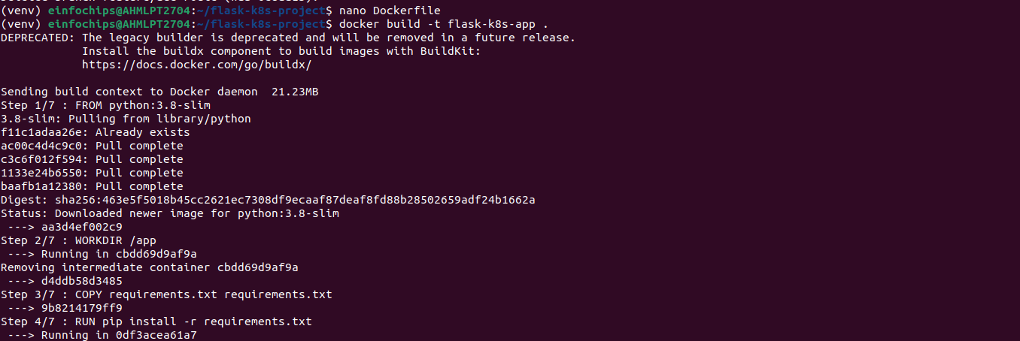

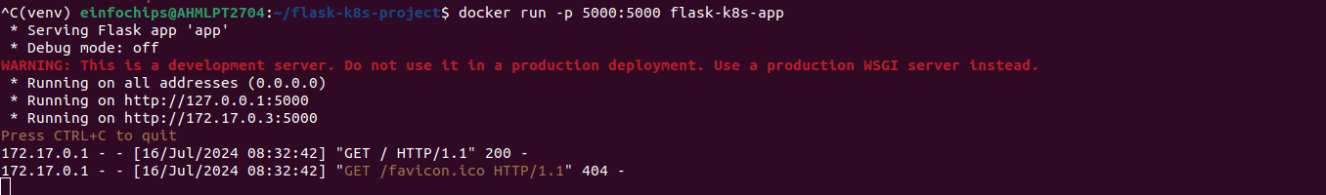

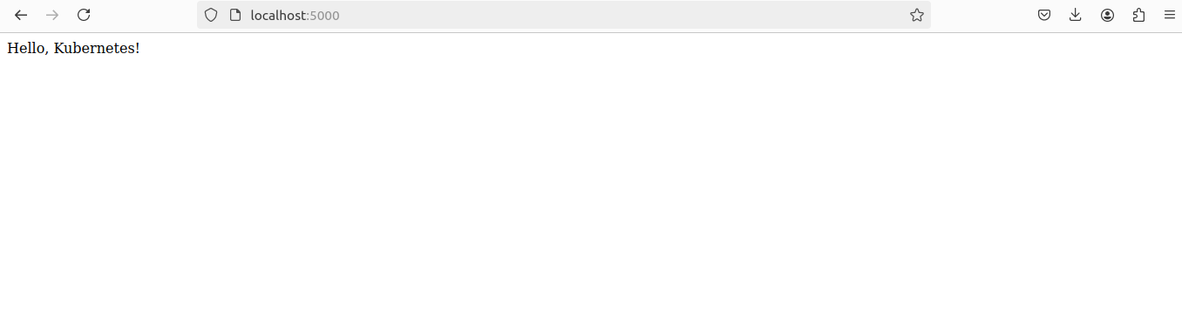

### **4. Deploying to Minikube Kubernetes**

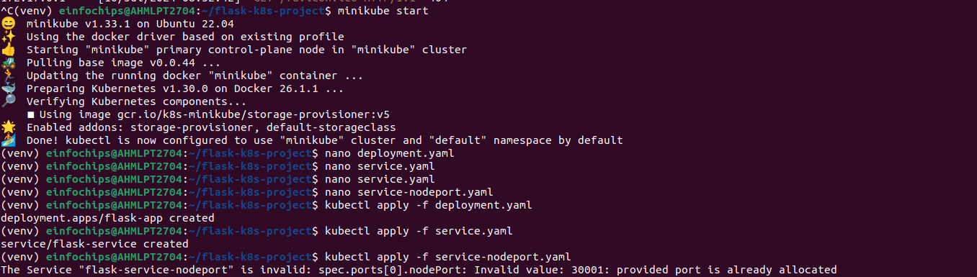

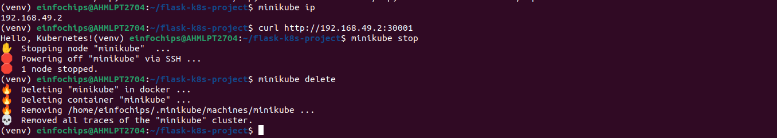

### **6. Making Changes to the Flask Application**

